**LESSON GUIDES FOR TOP CLASS**

**GENERAL KNOWLEDGE TERM THREE 2020**

**WEEK 1** **ORIENTATION**

**WEEK 2**

**PD 1** **People found at school**

**Activities**

* Identifying
* Naming
* Drawing
* Reading
* Talking about people found at school and their role

**PD 2** **People found at school**

**Activities**

* Naming
* Drawing
* Blending and reading
* Name the pictures



**PD 3 People found at school**

**Activities**

* Reading
* Matching

nurse cleans the school

teacher treats sick children

cleaner teaches children

**PD 4** **People found at home**

**Activities**

* Naming people and their roles
* Blending and reading



mother father

**PD 5** **Things found at home**

**Activities**

* Answering oral questions
* Blending and reading
* 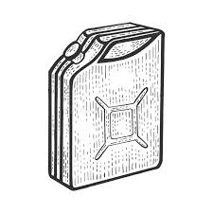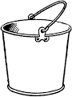[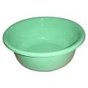](http://www.google.co.ug/imgres?imgurl=http://www.honrygroup.com/Plastic_Basin.jpg&imgrefurl=http://www.honrygroup.com/Honry-Links%20Your%20Plastic%20Materials.html&usg=__CgWEkmpZNapUSe3nQxJvTR-K8m4=&h=360&w=360&sz=15&hl=en&start=1&zoom=1&tbnid=qX99uOjvkK6thM:&tbnh=121&tbnw=121&ei=VJa2TcadOMedOtC-0JEP&prev=/search?q=plastic+basin&hl=en&sa=N&gbv=2&tbm=isch&itbs=1)Naming things found at home

**WEEK 3**

**PD 1** **Activities done at school**

**Activities**

* Answering questions
* Drawing
* Naming
* Talking about the activities done at different people at home

**PD 2** **Rooms in a house**

**Activities**

* Answering questions
* Identifying
* Talking about the different rooms found in a house and the things found there

**PD 3** **Basic needs**

**Activities**

* Reading
* Naming
* Circling the basic needs

leaf food gun

clothes grass bird

shelter tree cow

**PD 4** **Weather**

**Activities**

* Singing
* Acting
* 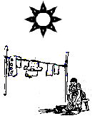Reading and drawing

sunny cloudy

windy rainy

**PD 5** **Weather**

**Activities**

* Blending and reading
* Drawing and naming
* Tick only the types of weather

sunny sunny same

rainy rat road

water windy well

**WEEK 4**

**PD 1**  **Weather**

**Activities**

* Identifying
* Naming
* Mentioning the things used during each type of weather

**PD 2** **Weather**

**Activities**

- Drawing

- Blending and reading

- Naming the things used during rainy weather

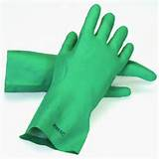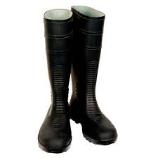

Identifying the elements of weather

( sun , rain, clouds , wind)

**PD 3**  **Transport**

**Activities**

- Identifying

- Naming

- Drawing

- Naming the different types of transport and their means

Road transport - cars , lorry, bicycle

Water transport - boat , ferry

Air transport - aeroplane jet

Railway transport - train

**PD 4** **Transport**

**Activities**

- Drawing

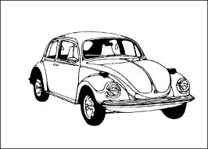- Naming the means of transport

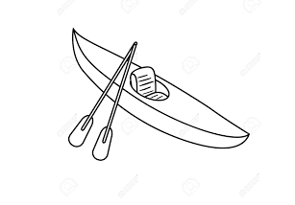

**PD 5**  **Transport**

**Activities**

- Blending , spelling and reading

- Drawing

- Read and draw

car boat

lorry aeroplane

train bus

**WEEK 5**

**PD 1** **Transport**

Activities

- Reading

- Identifying the means of transport and people who operate them.

Match correctly.

car captain

aeroplane driver

ship pilot

**PD 2** **Road signs**

**Activities**

- Reading

- Drawing

- Identifying the road signs

- Traffic lights - school ahead

- Parking - around about

- No parking - Zebra crossing

- Bridge

**PD 3**  **Road signs**

**Activities**

- Reading

- Naming

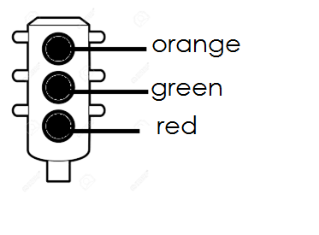- Drawing and shading the traffic lights

**PD 4** **Road signs**

**Activities**

- Naming

- Drawing the road sign

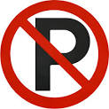

Parking No parking

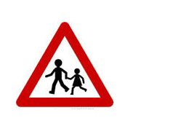

School ahead Zebra crossing

**PD 5** **Security**

**Activities**

- Role playing

- Asking and answering questions

- Talking about the people who help in security and the things they use

Gate keepers / Askari - gun , bows, dogs

Policemen - gun , batons etc

**WEEK 6**

**PD 1** **Communication**

**Activities**

- Blending and reading

- Drawing

- Talking about the ways of communication / things used in communication

television newspaper

[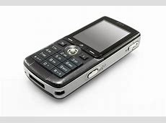](http://frugalfender.com/wp-content/uploads/2014/03/1254846_48220752.jpg)

telephone whistle

drum letter

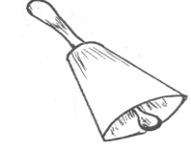

bell



radio

**PD 2** **Communication**

**Activities**

- Reading

- Circling the means of communication

shorts drum bell

telephone boat kite

ball newspaper letters

**PD 3** **Communication**

**Activities**

- Blending , reading and spelling

- Read and draw

bell television

drum telephone

radio

**PD 4** **Domestic birds**

**Activities**

- Blending and reading

- Naming

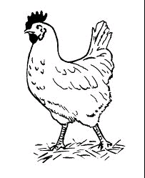- Circling the right word for the picture

duck hen

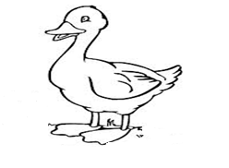

duck pigeon

**PD 5** **Domestic birds**

**Activities**

- Reading

- Drawing

duck hen

turkey pigeon

**WEEK 7**

**PD 1** **Domestic birds**

**Activities**

- Domestic birds

- Spelling and reading

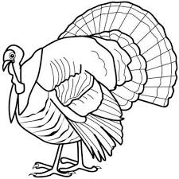- Naming

**PD 2** **Insects**

**Activities**

- Reading

- Naming

- Matching

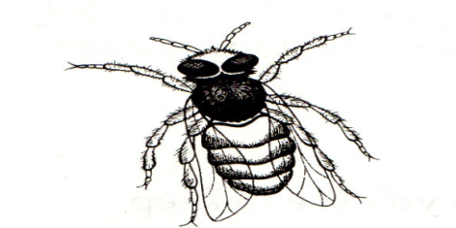 house fly

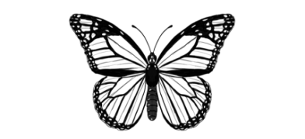 bee

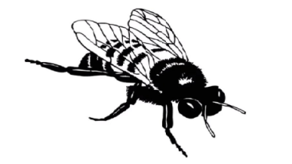

butterfly

**PD 3** **Insects**

**Activities**

- Reading

- Read and draw

spider ant

housefly bee

**PD 4** **Plants**

**Activities**

- Naming

- Reading

- Identifying plants

- banana plant - bean plant - maize plant

- cassava plant - sweet potato - mango plant

**PD 5** **Plants**

**Activities**

- Asking and answering questions

1. Which food do we get from maize?

2. Which plant gives us beans?

3. Which plant gives us banana leaves?

**WEEK 8**

**PD 1** **Living things**

**Activities**

- Naming

- Reading

- Drawing

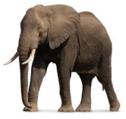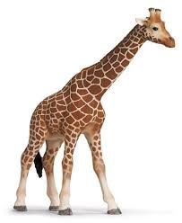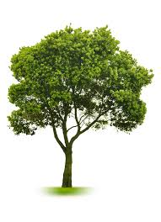

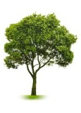 trees animals stones

**PD 2** **Non living things**

**Activities**

- Reading

- Drawing

- Identifying non living things

books , tables , tins , papers , leaves

**PD 3** **Things that can fly**

**Activities**

- Reading

- Demonstrating

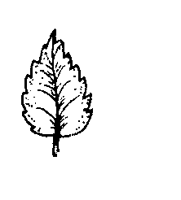- Name the things that can fly

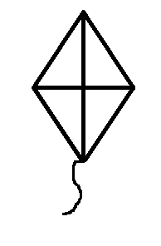

**PD 4** **Things that can fly**

**Activities**

- Identifying

- Reading

- Tick the things that can fly

beans birds boat

leaves land lamp

kettle kite kid

**PD 5** **Things that fly**

**Activities**

- Demonstrating

- Identifying

- Read and draw

insect bird

kite leaf

**WEEK 9**

**PD 1** **Things that float on water**

**Activities**

- Identifying

- Demonstrating

- Reading

- Mentioning the things that float on water

paper , box , leaves, stick , pen

Things that sink

stones , axe , hoe

**WEEK 9**

**PD 2** **Things that float on water**

**Activities**

- Reading

- Identifying

- Circle the things that float on water

leaf bell plate

man hammer paper

stick hoe cloth

**PD 3** **Things that sink in water**

**Activities**

- Reading

- Identifying

- Naming

- Circling the things that sink in water

axe tin bell

grass leaf hammer

**PD 4** **Our senses**

**Activities**

- Identifying , naming , drawing , copying

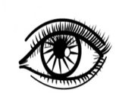

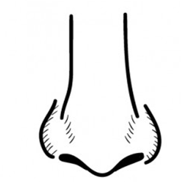 eyes to see.

nose to smell

**PD 5 Our senses**

**Activities**

- Reading

- Drawing

- Naming

- Match sense to their uses

for feeling

 for hearing

 for smelling

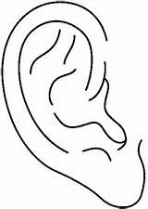 for tasting

 for seeing